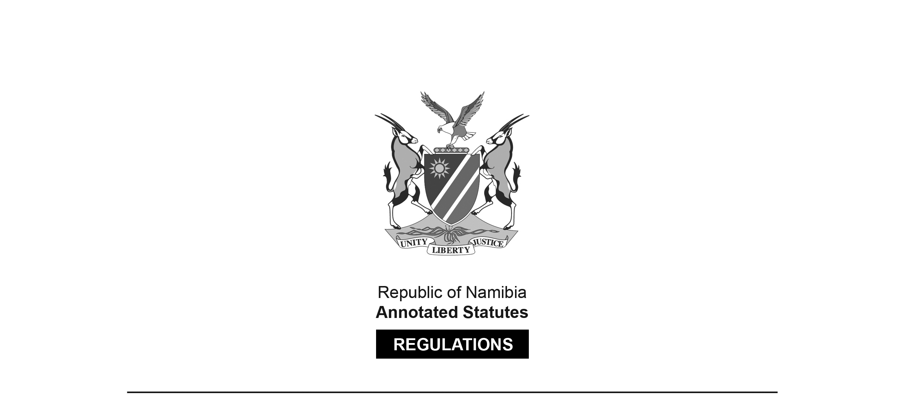

REGULATIONS SURVIVING IN TERMS OF

Banking Institutions Act 13 of 2023

section 109(3)

Regulations relating to Unfair Terms in Transactions   
or Contracts between Banking Institutions   
and Customers or General Public

Government Notice 296 of 2020

([GG 7395](http://www.lac.org.na/laws/2020/7395.pdf))

came into force on date of publication: 20 November 2020

These regulations were originally made in terms of section 71(1)(cA) of the Banking Institutions Act 2 of 1998, which was repealed by the Banking Institutions Act 13 of 2023. Pursuant to section 109(3) of the Banking Institutions Act 13 of 2023, the regulations are deemed to have been made in terms of that Act. The Government Notice which publishes these regulations notes that they were   
made on the recommendation of the Bank of Namibia.

ARRANGEMENT OF REGULATIONS

1. Definitions

2. Application of regulations

3. Unfair terms

4. Assessment of unfair terms

5. Written contracts

6. Governing principles

7. Persons to complain to Bank

8. Powers of Bank to prevent continued use of unfair terms

9. Effect of unfair terms

10. Powers of Bank to request or obtain documents and information

11. Publication, information and advice

12. Indicative and non-exhaustive list of terms which may be regarded as unfair

**Definitions**

**1.** In these regulations, a word or expression to which a meaning has been assigned in the Act bears that meaning and unless the context indicates otherwise -

“agent” means an entity that has been contracted by a banking institution and approved by the Bank to provide services on behalf of the banking institution;

“contract” means an agreement in writing, made between a banking institution and its customer, for the provision of financial products or services acquired for personal, commercial or any other use;

“customer” means a person to whom financial products and services are made available by a banking institution under a contract;

“document” means books, accounts and any information stored or recorded manually, electronically, digitally, photographically, magnetically, mechanically, optically or in any other form;

“excluding or limiting the liability” means -

(a) making a right or remedy in respect of a liability subject to a restrictive or onerous condition except in circumstances where that condition;

(b) excluding or restricting a right or remedy in respect of a liability, except in circumstances where that exclusion or restriction;

(c) putting a person at a disadvantage if he or she pursues a right or remedy in respect of a liability except in circumstances where putting that person at a disadvantage; or

(d) excluding or restricting rules of evidence or procedure except in circumstances where that exclusion or restriction,

is justifiable under any law of Namibia;

“main subject matter of the contract” includes -

(a) any asset involved in the contract;

(b) the interest rate charged, by a banking institution, under the contract;

(c) the repayment period specified in the contract;

(d) the sum to be repaid, by a customer, specified in the contract; and

(e) any collateral offered, by or on behalf of a customer and accepted by a banking institution, in terms of the contract;

“notified” means informed in writing by means of a formal letter delivered to the Bank, a banking institution or a customer;

“the Act” means the Banking Institutions Act, 1998 (Act No. 2 of 1998);

[The Banks Act 23 of 1965 has been replaced by the Banking Institutions Act 2 of 1998,   
which has been replaced in turn by the Banking Institutions Act 13 of 2023.]

“undertaking” means a written commitment from a banking institution to take any action or discontinue any action, as ordered by the Bank under regulation 8(4);

“unfair terms” means the contractual terms referred to in regulation 3; and

“working day” means any day in Namibia excluding a Saturday, Sunday or public holiday specified in the Public Holidays Act, 1990 (Act No. 26 of 1990).

**Application of regulations**

**2.** These regulations apply to a contract between a banking institution and its customer regardless of whether that contract is subject to the laws of a foreign State or not.

**Unfair terms**

**3.** (1) A contractual term which has not been individually negotiated is considered to be unfair if, contrary to the requirement of good faith, it causes any imbalance in the rights and obligations of the parties, arising under the contract to the disadvantage of the customer.

(2) A contractual term is considered as not having been individually negotiated if a banking institution does not give a customer at least five working days to read, understand and negotiate, if necessary, the substance of the contract.

(3) After the terms in the contract have been individually negotiated, the customer must sign an acknowledgement form attesting that the contract was explained to him or her.

(4) In the event that a customer immediately requires a service or product of a banking institution, the customer must provide a statement in writing acknowledging that the contract was explained to him or her and also that the banking institution offered him or her at least five working days to read and understand the contract.

(5) Despite the fact that a specific term or a certain aspect of a term in a contract has been individually negotiated, the contract must be regarded as based on unfair terms if an overall assessment of such contract indicates that it contains any unfair term.

(6) When considering investigating whether a particular term is unfair, the onus is on the aggrieved customer to provide proof to the Bank that the term is unfair.

**Assessment of unfair terms**

**4.** The unfairness of a contractual term must be assessed by, among others, taking into account the object or effect of a term as outlined in regulation 12.

**Written contracts**

**5.** (1) A banking institution must, as far as possible, ensure that any written term of a contract is expressed and explained to the customer, in plain and simple English.

(2) If the customer does not understand plain and simple English, the banking institution must explain to the customer the terms and conditions of the agreement in a language which the customer understands, if necessary with the assistance of an interpreter provided by the customer

[There is a full stop missing at the end of subregulation (2).]

(3) Where it is considered necessary to include legal concepts or technical terms in a contract, the meaning of the concepts and terms must be clearly defined in the contract.

**Governing principles**

**6.** The Board of Directors of each banking institution is responsible for establishing policies and procedures which are adequate to ensure that these regulations are complied with.

**Persons to complain to Bank**

**7.** (1) A natural person who enters into a contract with a banking institution regarding the provision of banking services may, in writing or in a manner determined by the Bank, complain to the Bank against the banking institution about unfair terms in the contract.

(2) Despite subregulation (1), only juristic persons with an annual turnover of less than N$1 000 000 may complain to the Bank regarding the unfairness of the term in a contract.

**Powers of Bank to prevent continued use of unfair terms**

**8.** (1) The Bank may investigate any complaint made in terms of these regulations that any contractual term is unfair.

(2) If a complaint contemplated in subregulation (1) is made against a banking institution, the Bank must -

(a) request that banking institution to explain in writing, within 15 working days after receipt of that request, the reasons for the continued use of the unfair term in contracts concluded with customers; and

(b) consider the reasons requested under paragraph (a), if any, when determining the complaint.

(3) The Bank has the power to determine whether a particular term is unfair or not.

(4) If the Bank, either under subregulation (3) or through its own assessment, determines a particular term to be unfair, the Bank must order the banking institution concerned to -

(a) cease the use of the unfair term; or

(b) revise the unfair term so as to remove the element of unfairness.

(5) An order issued under subregulation (4) may relate not only to the use of a particular contractual term contemplated in that subregulation but to any similar term or a term having similar effects or meaning, used or recommended for use by a banking institution in contracts entered into after the effective date of these regulations.

**Effect of unfair terms**

**9.** (1) A term in a contract entered into between a banking institution and a customer and determined by the Bank to be unfair is not be binding on the customer.

[The word “be” is superfluous; the provision should read “is not binding”.]

(2) A banking institution with a contract containing unfair terms as determined by the Bank under regulation 8(4) must in writing indicate to the Bank, within 15 working days after the Bank determines the terms to be unfair, that it will not rely on such terms.

(3) A banking institution must indicate, in the undertaking referred to in subregulation (2), its action plan to either amend the term so it is no longer unfair or delete it from its contracts in the future.

(4) Where a banking institution has given an undertaking referred to in subregulation (2), the banking institution must promptly notify customers with whom it has already concluded contracts with a similar term to inform them about the effect of such term on their contracts.

**Powers of Bank to request or obtain documents and information**

**10.** (1) In exercising its mandate under these regulations, the Bank may request any documents and information from a banking institution for the purpose of -

(a) facilitating the consideration of a complaint that a term in a contract is unfair; or

(b) ascertaining whether a banking institution has complied with an order issued by the Bank as to the continued use or recommendation for use, of a term in contracts concluded with customers.

(2) A request made under subregulation (1) must be made in writing and must specify the manner and time within which the request must be complied with.

**Publication, information and advice**

**11.** (1) The Bank must publish on its website and in the print media -

(a) details of the order made by the Bank under regulation 8(5); and

(b) details of any undertaking notified to the Bank as to the continued use by a banking institution of a term which the Bank considers to be unfair in contracts concluded with customers.

(2) The Bank may disseminate any information and advice concerning the operation of these regulations to the public and to all persons likely to be affected by these regulations.

(3) Before making available information as contemplated in subregulation (1) or (2), the Bank must, on request by any affected party, delete any information which that party considers to be -

(a) confidential information with commercial value;

(b) information that may not be released as it is against the public interest; or

(c) information that consists of personal details of an individual.

**Indicative and non-exhaustive list of terms which may be regarded as unfair**

**12.** (1) Terms may be regarded as unfair if they have the object or effect of -

(a) excluding or limiting the liability of a banking institution, in the event of death of a customer or from an intentional act or omission on the part of that banking institution;

(b) excluding or limiting the legal rights of the customer against a banking institution or another party in the event of total or partial non-performance or inadequate performance by the banking institution of any of the contractual obligations, except in cases were such non-performance is as a result of a natural catastrophic event;

(c) permitting a banking institution to retain an amount of money paid by the customer in the case where the customer decides not to conclude or perform the contract when there was a misrepresentation by the banking institution on the main subject matter of the contract;

(d) permitting a banking institution to retain the amount of money paid for services that were not rendered, in cases where it is the banking institution itself that cancelled the contract;

(e) enabling a banking institution to terminate a contract with a customer without at least five working days’ notice, except where there is a valid reason, such as money laundering, and provided that the banking institution informs the customer immediately after such termination;

(f) automatically extending a contract of fixed duration where a customer does not indicate otherwise, when the period fixed for the customer to express his or her desire to or not to extend the contract is less than five working days;

(g) irrevocably binding a customer to a contract without giving the customer at least five working days to become acquainted with the content of the contract before the conclusion of such contract;

(h) enabling a banking institution to revise or remove any term in the contract unilaterally, except where the banking institution has been ordered by the Bank to revise or remove such term on the ground of unfairness;

(i) enabling a banking institution to unilaterally alter any features of the product or service without consulting and obtaining approval of the customer;

(j) providing for the price of products or services to be determined at the time of delivery or allowing a banking institution to increase their price without, in both cases, giving a customer the corresponding right to cancel the contract if the final price is high in relation to the price agreed when the contract was concluded;

(k) giving a banking institution the exclusive right to -

(i) determine whether the products or services supplied by the banking institution are in conformity with the contract; or

(ii) interpret any term of the contract;

(l) limiting any obligation of a banking institution in respect of commitments undertaken by its agents;

(m) requiring the customer to fulfil all his or her obligations where a banking institution does not perform its obligations;

(n) giving a banking institution an option of transferring its rights and obligations under the contract to a third party without the consent of its customer where the transferred rights and obligations are susceptible to a reduction of the obligations of the banking institution to the customer;

(o) excluding or hindering the right of a customer to take legal action or to exercise any legal remedy against a banking institution, other than in circumstances where that exclusion is justified by any law of Namibia; or

(p) prejudicing or being potentially prejudicial to, the interest of a customer by any means other than that set out in paragraphs (a) to (o).

[The comma after the word “to” is superfluous; alternatively, there should be a comma before   
the phrase “or being potentially prejudicial to” to offset that phrase properly.]

(2) Subregulation (1)(i) and (j) does not apply to -

(a) transactions in transferable securities, financial instruments and other products or services where the price is linked to fluctuations in stock exchange quotation or index or a financial market rate that a banking institution does not control; and

(b) contracts for the purchase or sale of foreign currency or international money orders denominated in foreign currency;

[The semi-colon at the end of paragraph (b)should be a full stop.]

(3) Subregulation (1)(j) does not apply to lawful price indexation clauses, if the method by which prices vary is explicitly described.